3-2 Milestone Two: Enhancement One: Software Design and Engineering

David Ruth
Southern New Hampshire University
CS-499-18323-M01 Computer Science Capstone 2024
Professor Mike Alesso, M.Sc.
11/14/2024

Narrative
1) Briefly describe the artifact. What is it? When was it created?
The artifact that will be enhanced is a full-stack web application using MEAN stack called Travlr Getaways. It is designed as a travel booking site for customers to browse and book travel packages. Customers can create accounts and look through travel locations, rooms, and more. There is also an admin-only SPA for maintaining customer accounts, travel packages, and items within. This application was created as a college project from 09/2024 to 11/2024.

2) Justify the inclusion of the artifact in your ePortfolio. Why did you select this item? What specific components of the artifact showcase your skills and abilities in software development? How was the artifact improved?
This full-stack web application was selected for my ePortfolio because it represents an accumulation of skills acquired through the computer science program. These skills include working with APIs, full-stack development with the back-end Node.js and Express as well as front-end Angular, database management, and debugging and error-handling.
The artifact was improved with the implementation of the mailing service. This service allows a user to enter their email in the homepage to receive a welcome email from Travlr Getaways. Once the user enters their email, a JavaScript sends a POST request to the RESTful API after validating the data. This request is validated on the back-end Node.js server as well then calls the mailing service to send an email using NodeMailer. A response on is sent back to the front-end to confirm to user if the email was successful. For a testing and debugging environment, emails are captured using mailtrap.

3) Did you meet the course outcomes you planned to meet with this enhancement in Module One? Do you have any updates to your outcome-coverage plans?
The course outcome selected in the enhancement plan was “Demonstrate an ability to use well-founded and innovative techniques, skills, and tools in computing practices for the purpose of implementing computer solutions that deliver value and accomplish industry-specific goals”. This goal was met in several ways, but primarily in:
- The use of using third-party services such as mailtrap for creating a testing and debugging environment where outputs could be contained.
- Through compartmentalizing functions to be called such as mailing.js containing the mailing service script to be called in the HTML homepage.
- Validating and sanitizing user inputs both in the front-end and data entering the back-end. This was done using the npm validation module.
The enhancement outcome did differ from the established plan. The original plan was:
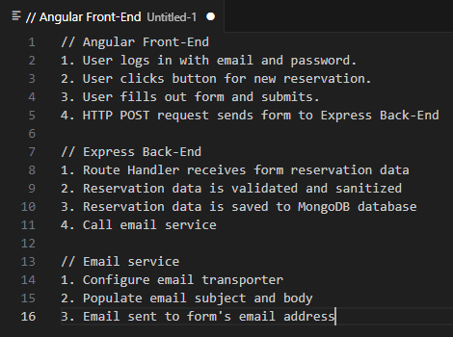
This plan had several steps that were discarded or reallocated to another enhancement. First, the user is no longer required to log in with their email and password. Second, the user is only required to input their email into the form. Third, validation and sanitizing is a step in both the front-end and back-end for the email string data. Fourth, the email service works as intended, but sends a welcome email.
The reason for this is the workload to complete the intended functions would be out of scope for this enhancement and will instead be allocated to Enhancement Three Databases instead of the intended plan:
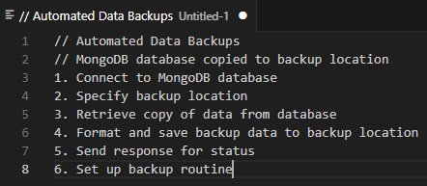
The plan now updated for Enhancement Three is now to expand Enhancement One to allow users to fill out an expanded form for creating a reservation. This reservation will include the user data of name, email, reservation date, and travel package. The reservation data will then be stored within the MongoDB database for admin retrieval. Once the reservation is complete, the user will receive an email containing the reservation data to verify for their records.

4) Reflect on the process of enhancing and modifying the artifact. What did you learn as you were creating it and improving it? What challenges did you face?
The process to enhance the artifact involved researching brand new topics on the intended functions never used before. The mailing service uses nodemailer to send emails in the Node.js server to SMTP provider mailtrap for safely testing and debugging during development. This involved learning SMTP and the process of mail transmission. There were many challenges that came from this, but the primary one was debugging failed email transmissions. The solution was to use Postman to send POST requests. This narrowed down if the errors received were a disconnect between the front-end to back-end or back-end to the SMTP provider.
